Credentials I need:
- MySQL db username and password
- Gmail and the 16 digits app passwords
- Go to https://aistudio.google.com/app/api-keys , click on Create API key, then copy me the key
Example of creating API key:
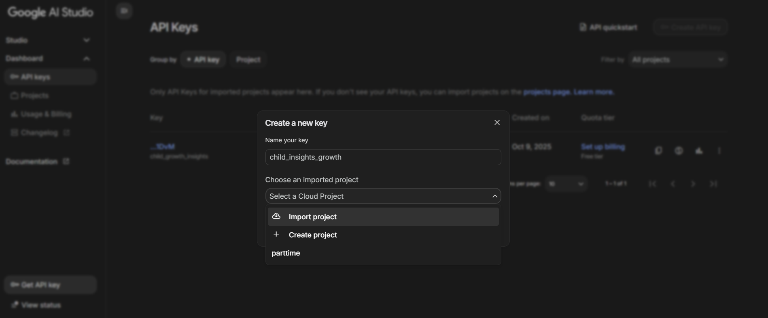
- Put your own name (can be anything)
- For “Choose an imported project”, select “Create Project”
Then just Create new project (any name you like)
